Digital Logic

Practical

Lab Report

Comparator Circuit and Parity Checker/Generator

Student:

Abhiroop Mukherjee

Teacher:

Prof. Surajeet Ghosh

Prof. Sekhar Mandal

Course:

Digital Logic Laboratory (CS351)

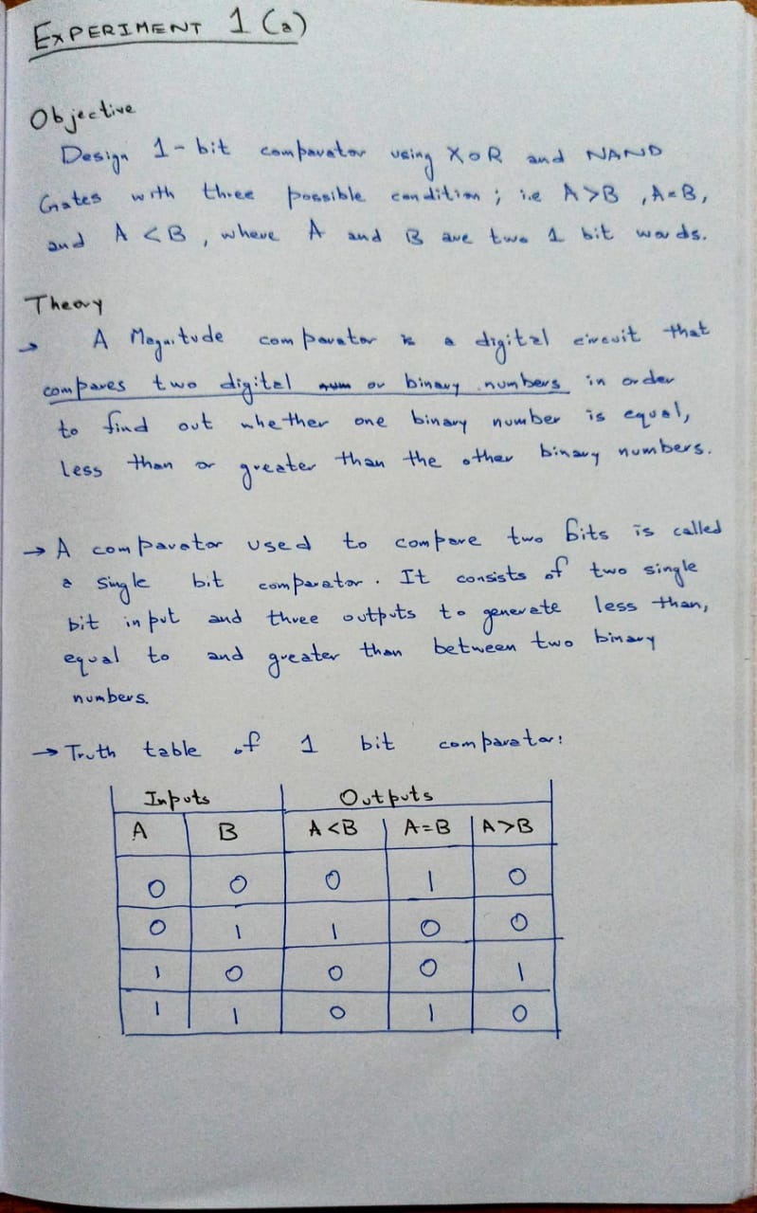

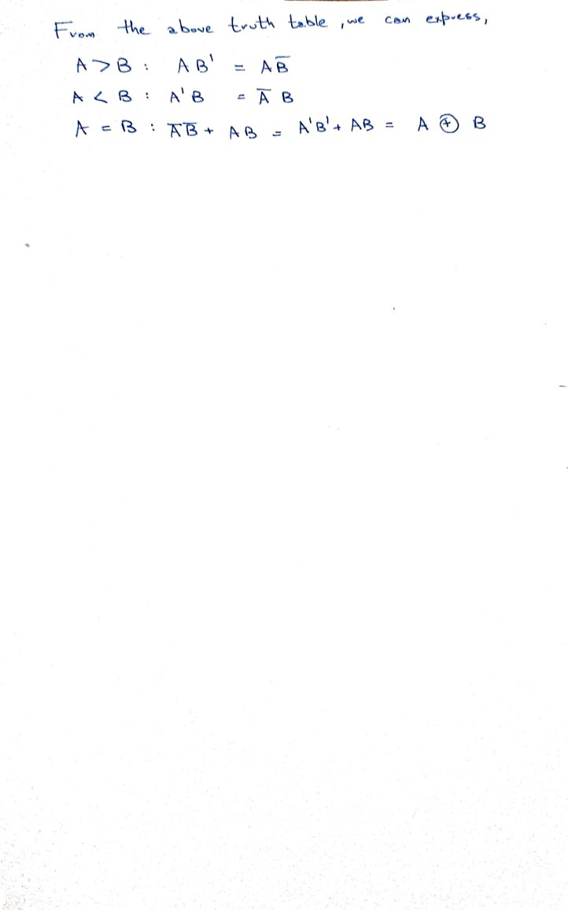

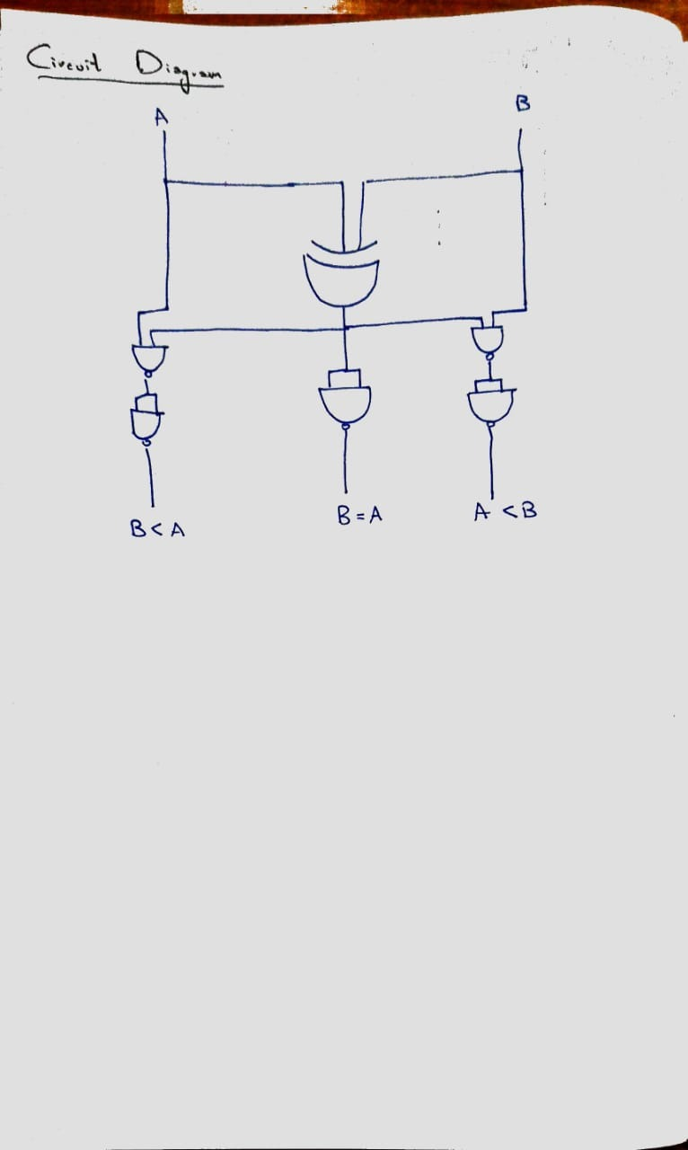

## Input/Output

## 

Figure 4: A=1; B = 1

Figure 3: A = 1; B = 0

Figure 2: A = 0; B = 1

Figure 1: A = 0; B = 0

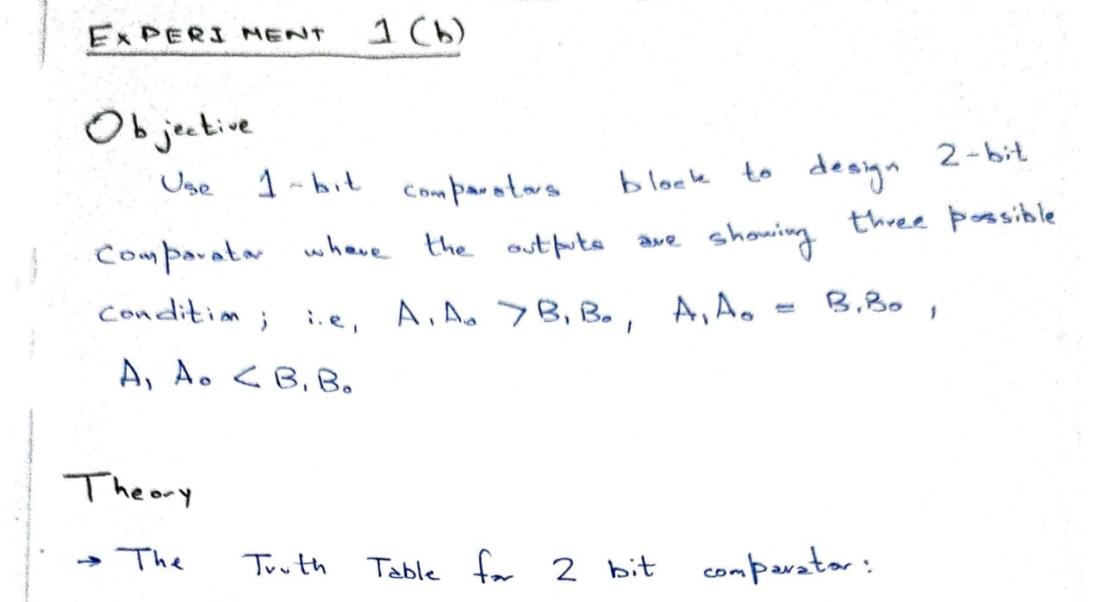

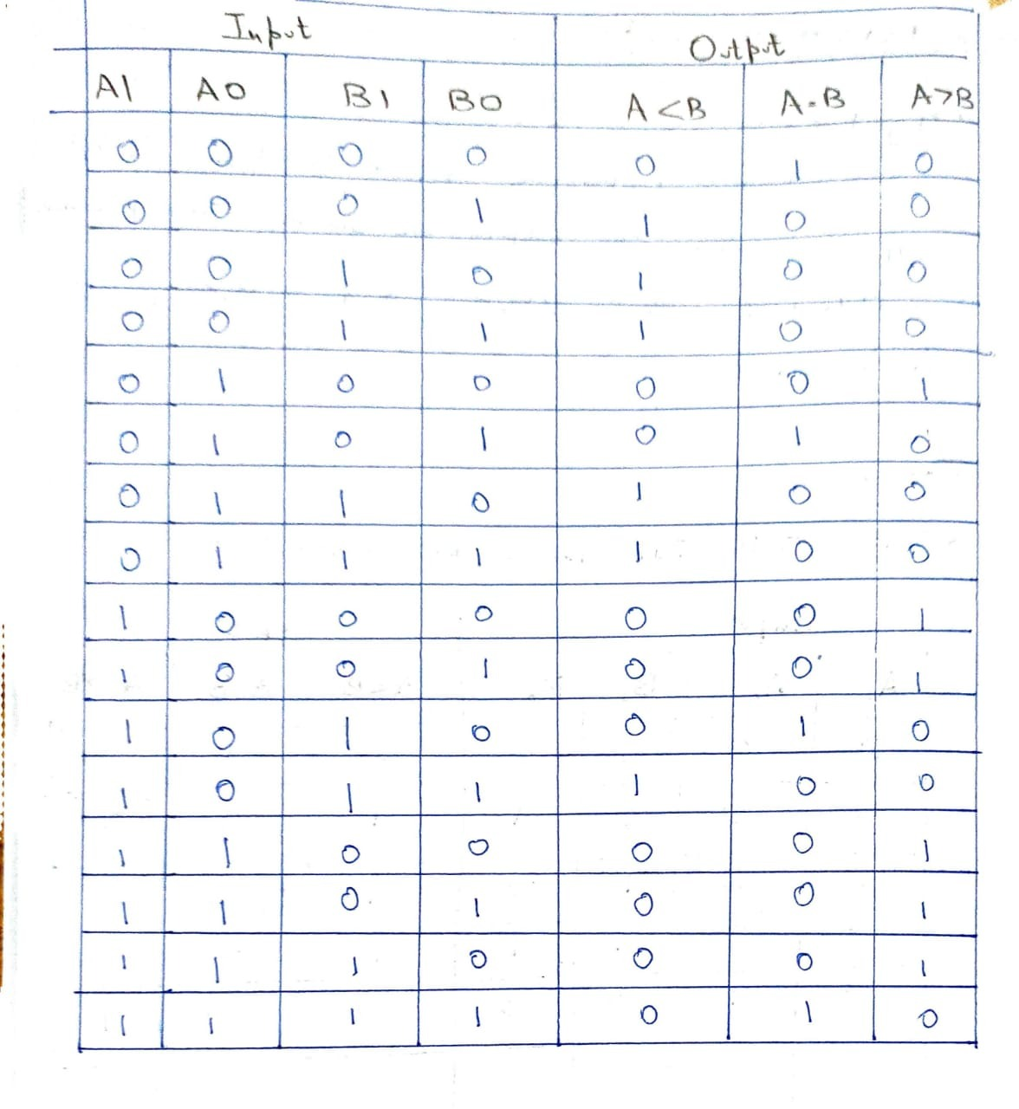

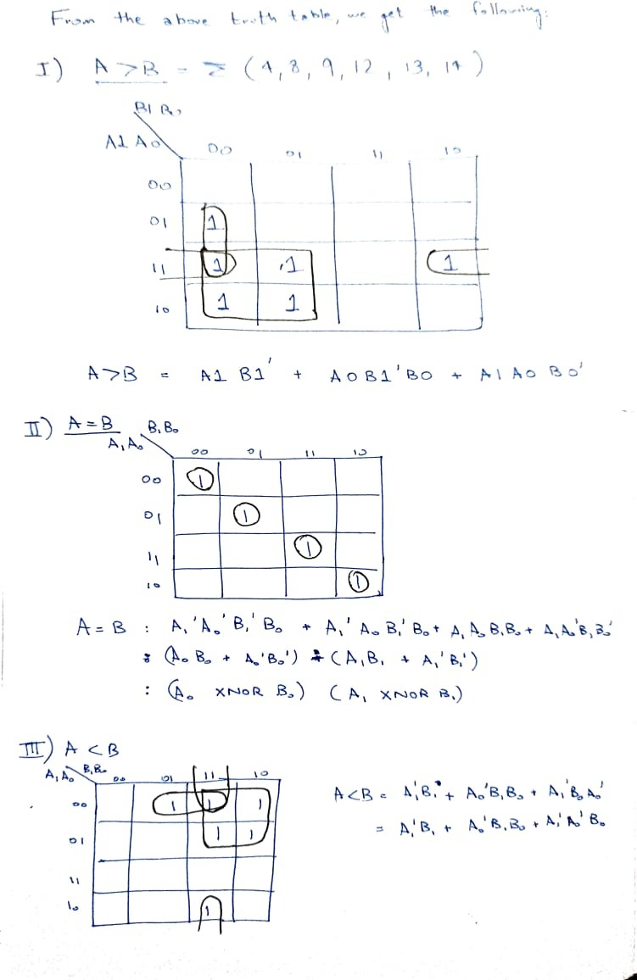

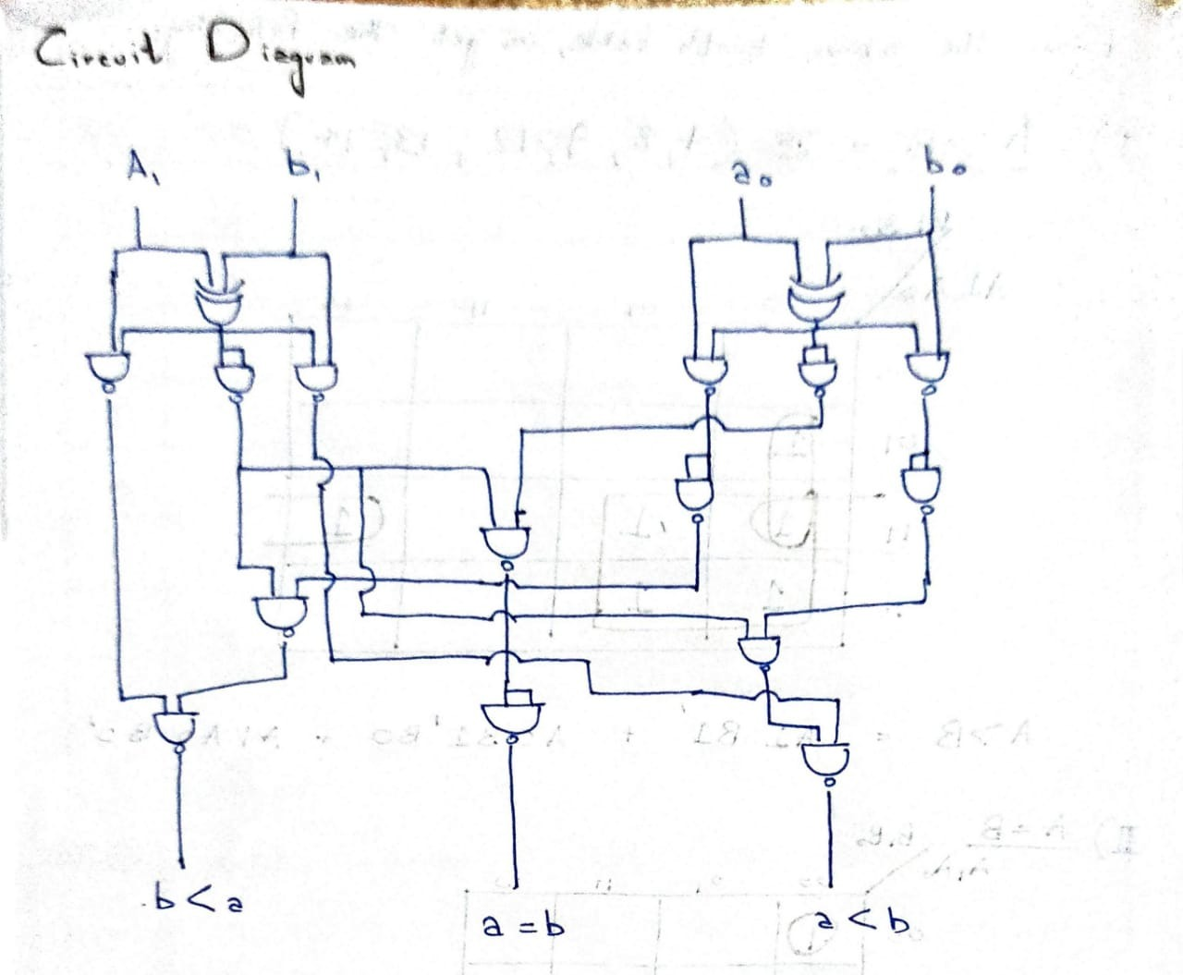

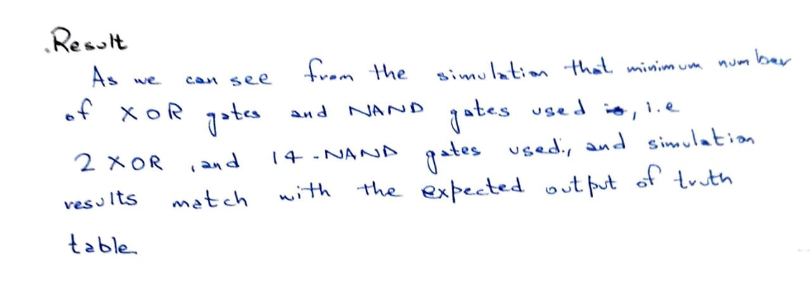

## Input / Output

Figure 1: a1 = 0; a0 = 0; b1 = 0; b0 = 0

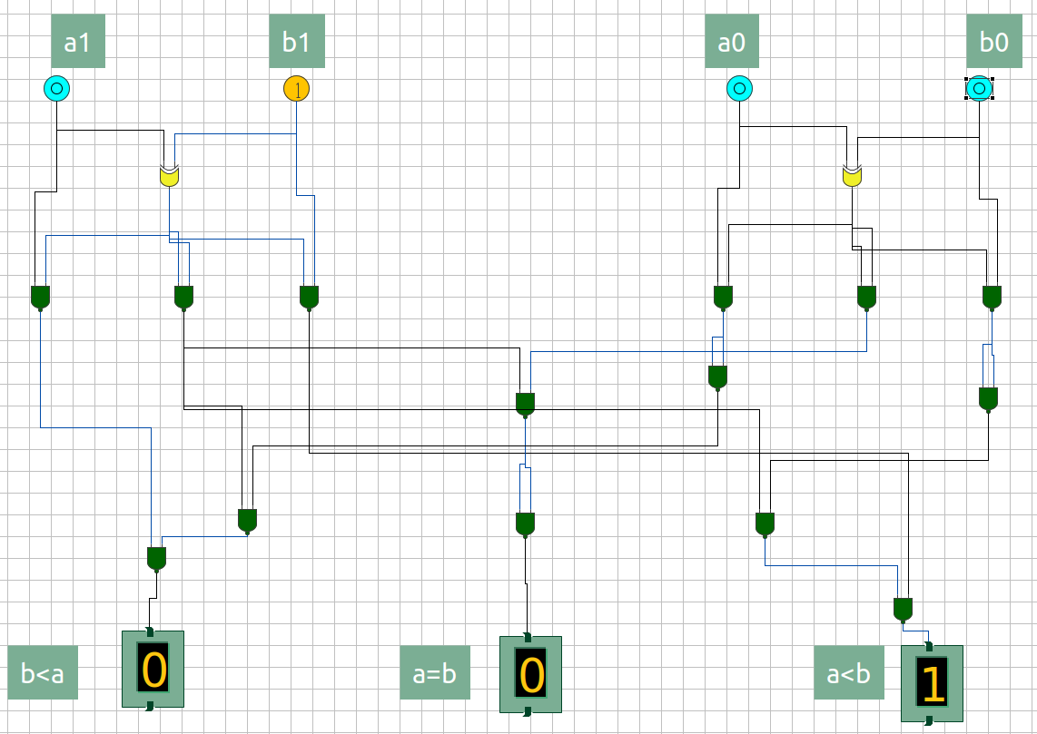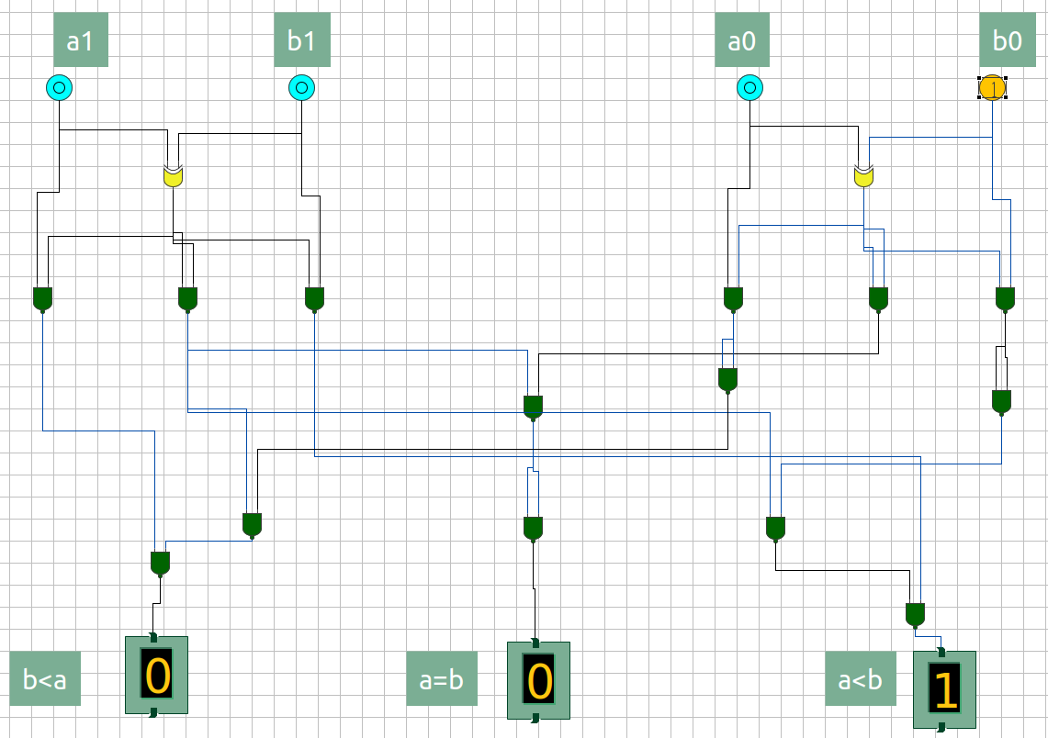

Figure 3: a1 = 0; a0 = 0; b1 = 1; b0 = 0

Figure 3: a1 = 0; a0 = 0; b1 = 0; b0 = 1

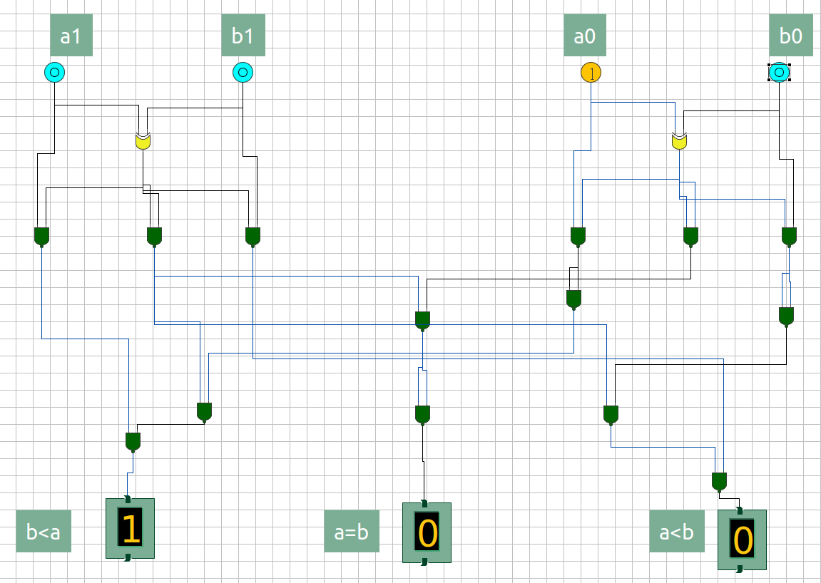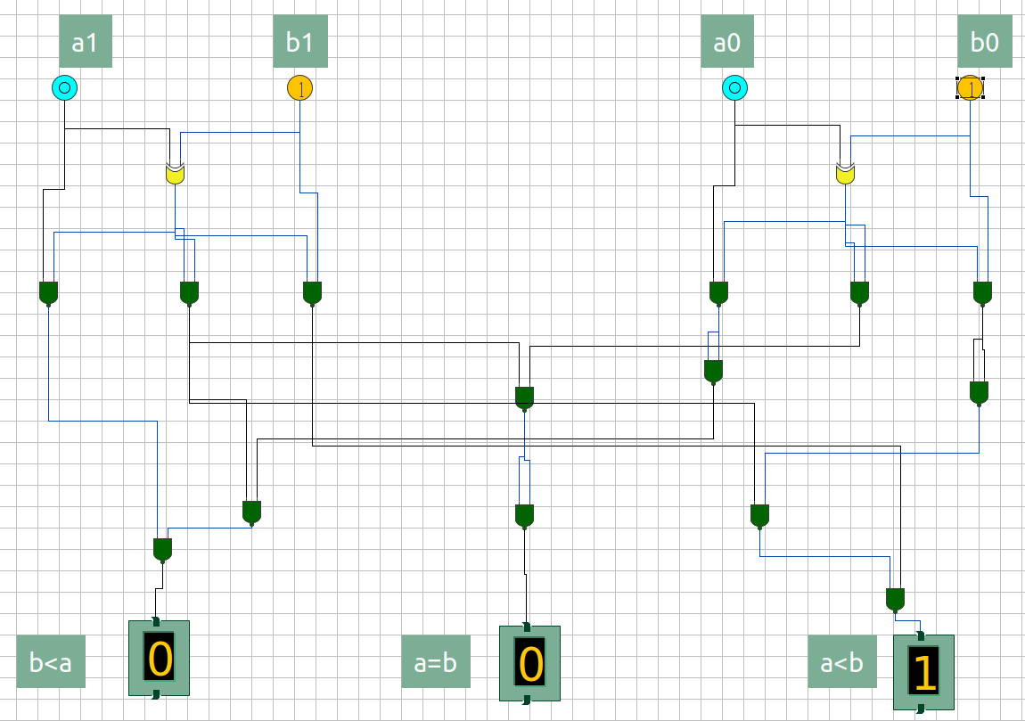

Figure 5: a1 = 0; a0 = 1; b1 = 0; b0 = 0

Figure 4: a1 = 0; a0 = 0; b1 = 1; b0 = 1

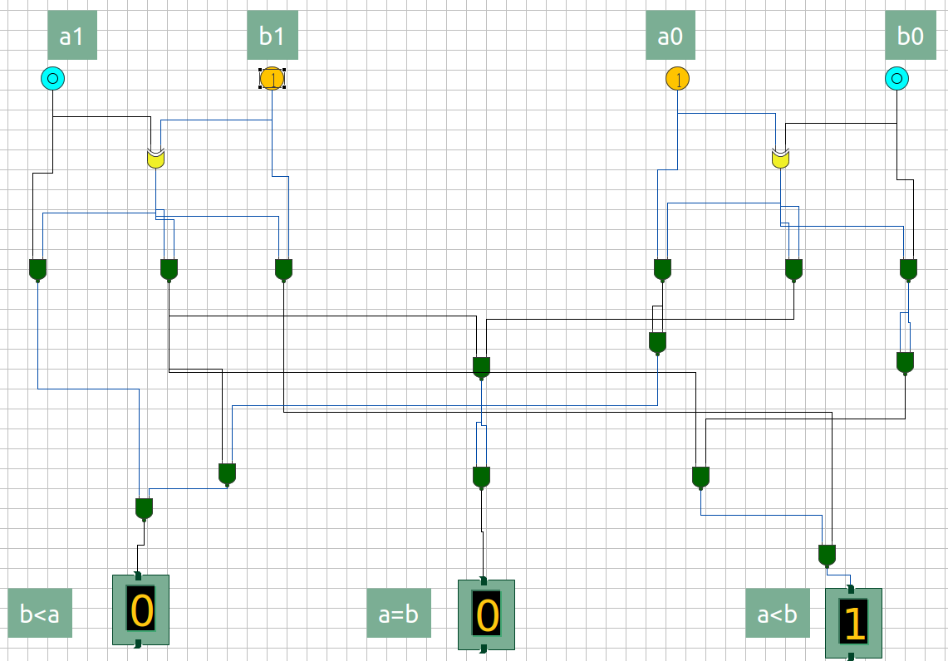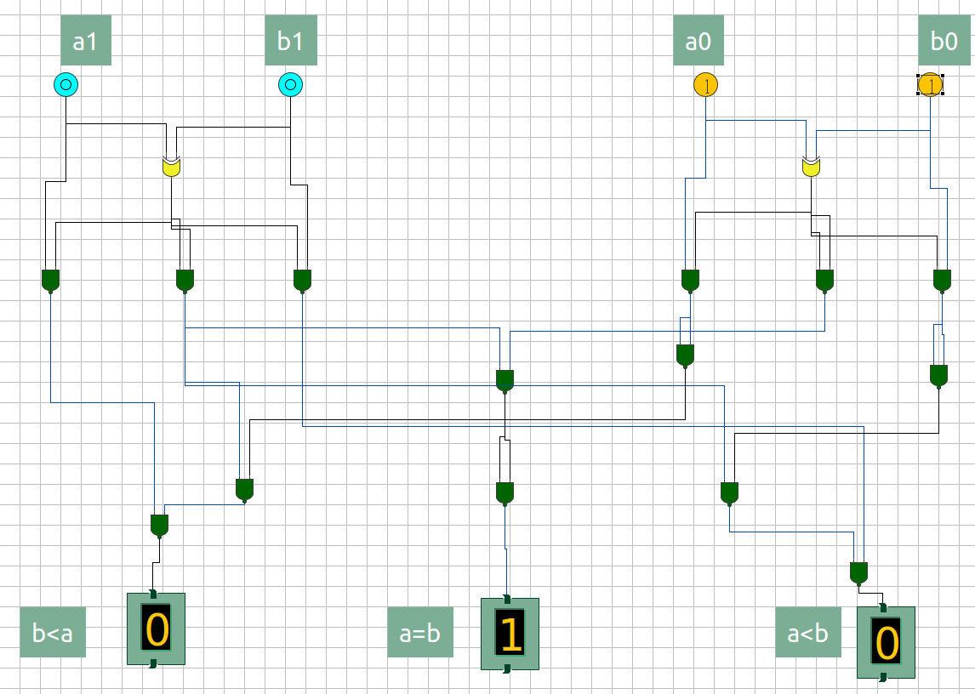

Figure 6: a1 = 0; a0 = 1; b1 = 0; b0 = 1

Figure 7: a1 = 0; a0 = 1; b1 = 1; b0 = 0

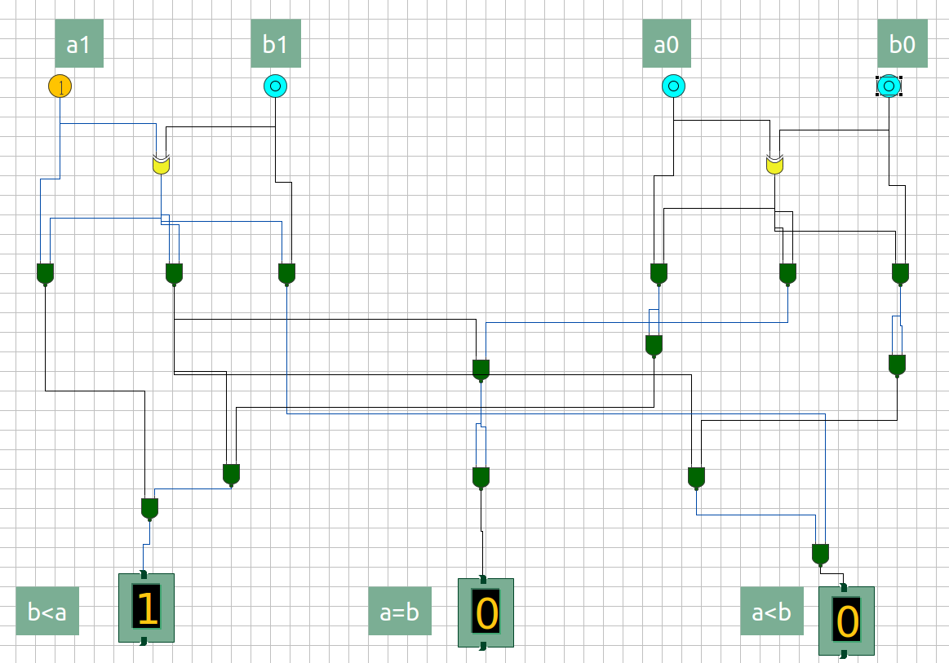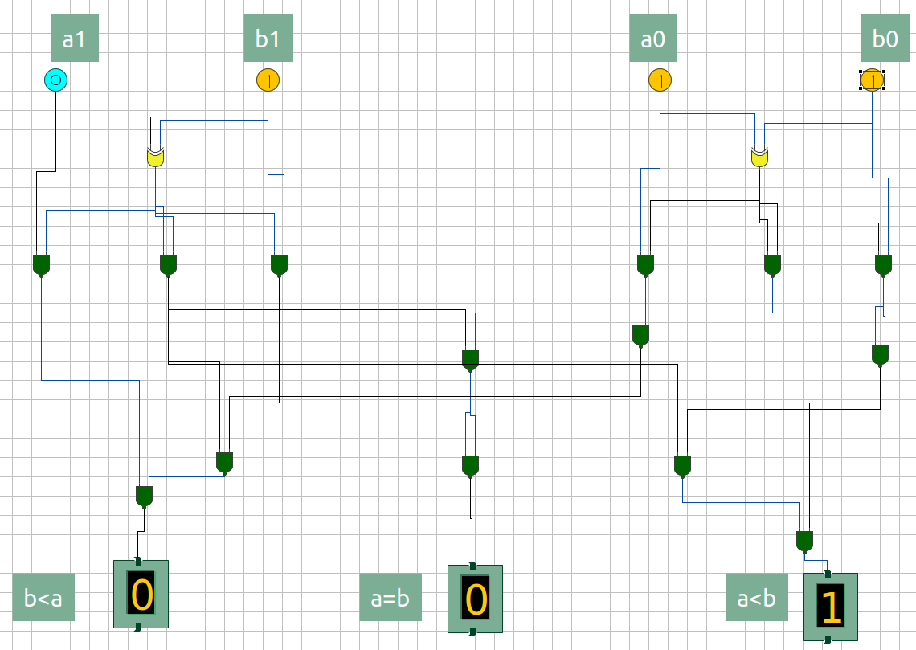

Figure 8: a1 = 0; a0 = 1; b1 = 1; b0 = 1

Figure 9: a1 = 1; a0 = 0; b1 = 0; b0 = 0

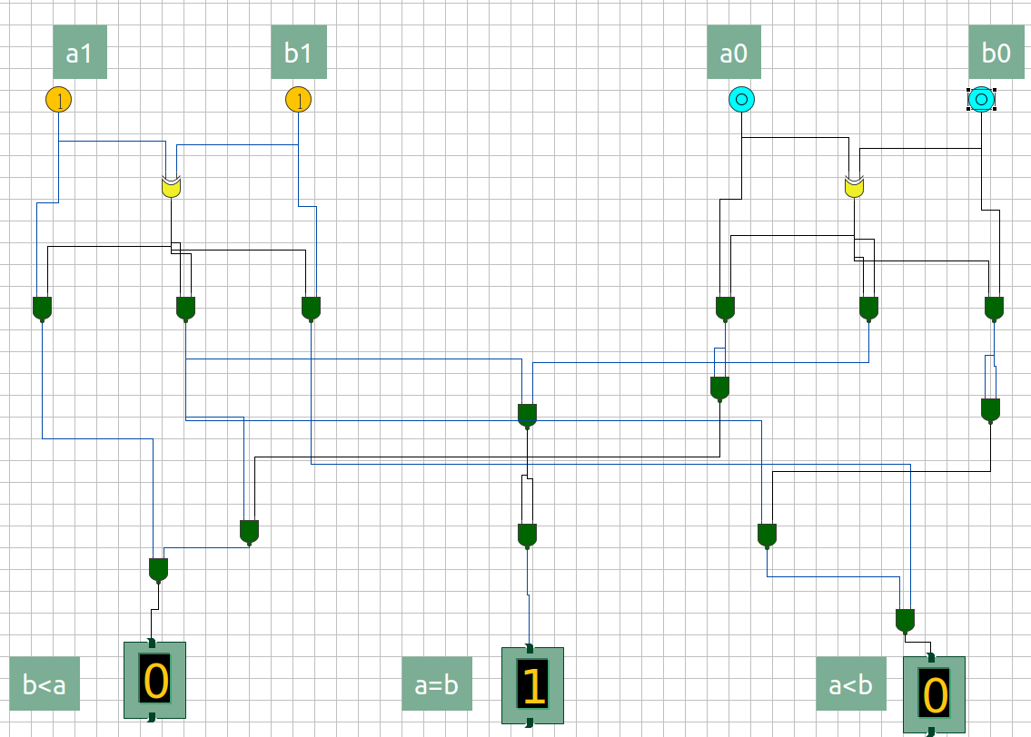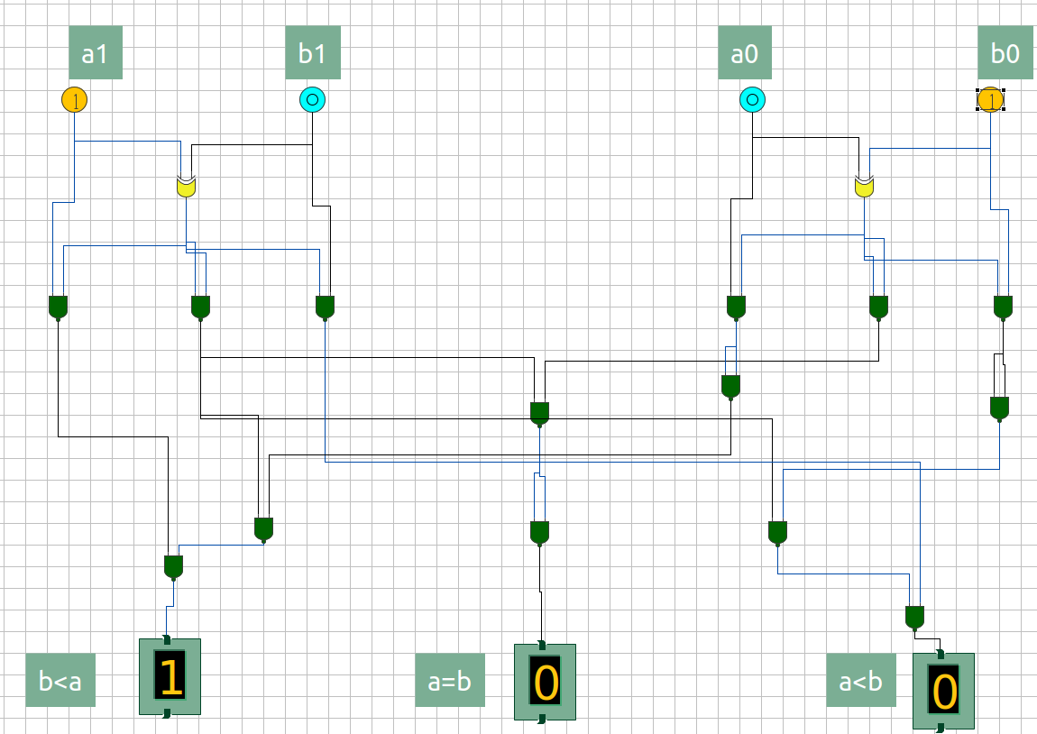

Figure 11: a1 = 1; a0 = 0; b1 = 1; b0 = 0

Figure 10: a1 = 1; a0 = 0; b1 = 0; b0 = 1

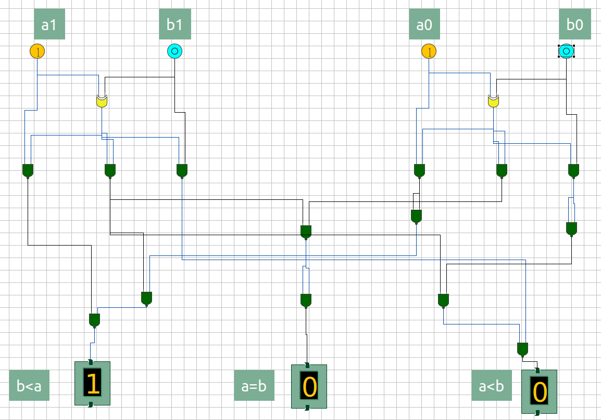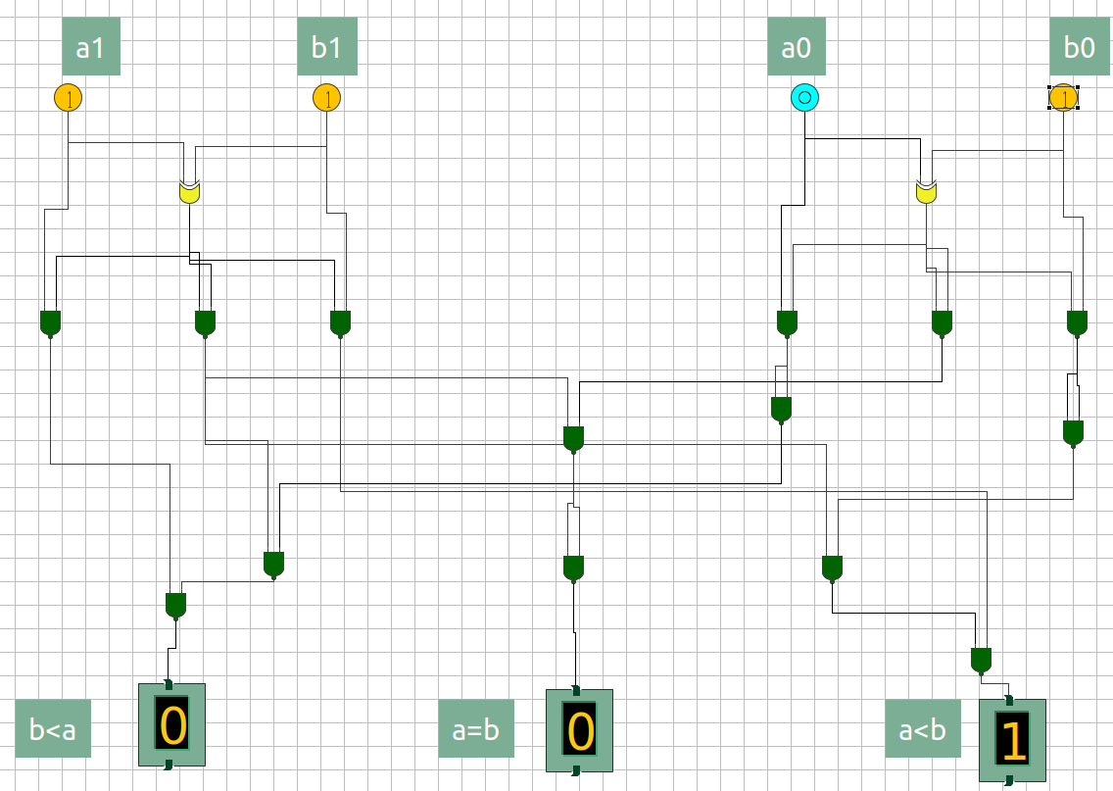

Figure 13: a1 = 1; a0 = 1; b1 = 0; b0 = 0

Figure 12: a1 = 1; a0 = 0; b1 = 1; b0 = 1

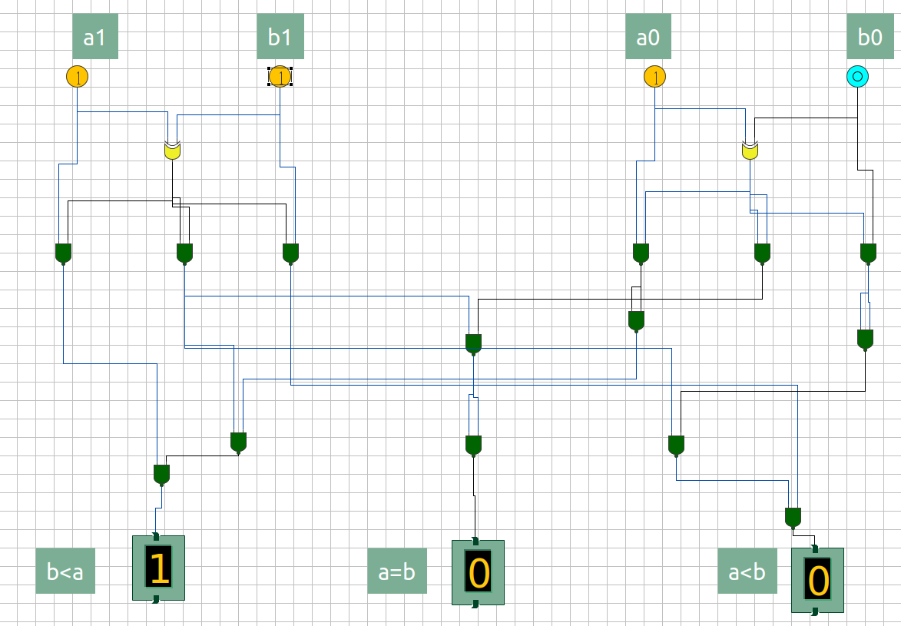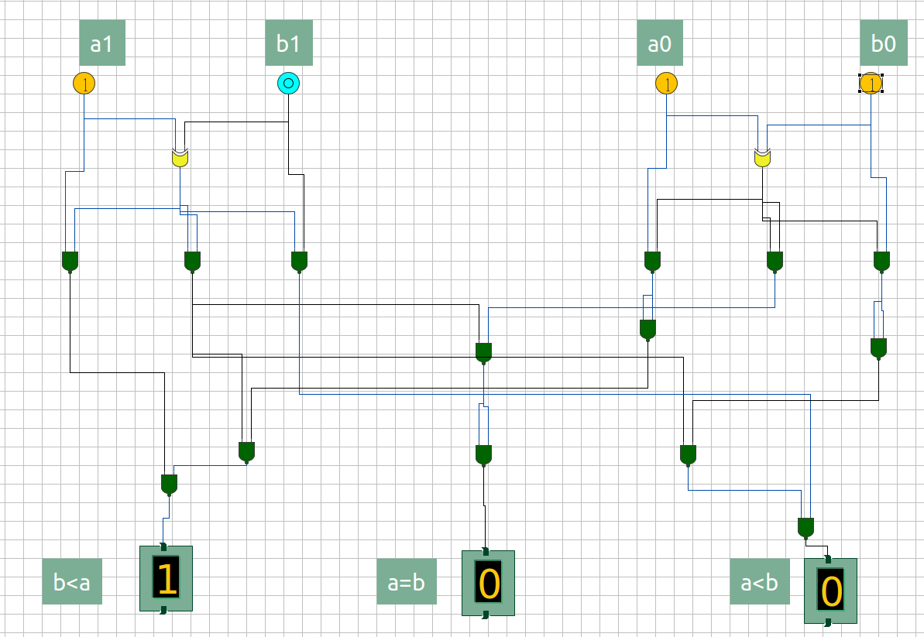

Figure 14: a1 = 1; a0 = 1; b1 = 0; b0 = 1

Figure 15: a1 = 1; a0 = 1; b1 = 1; b0 = 0

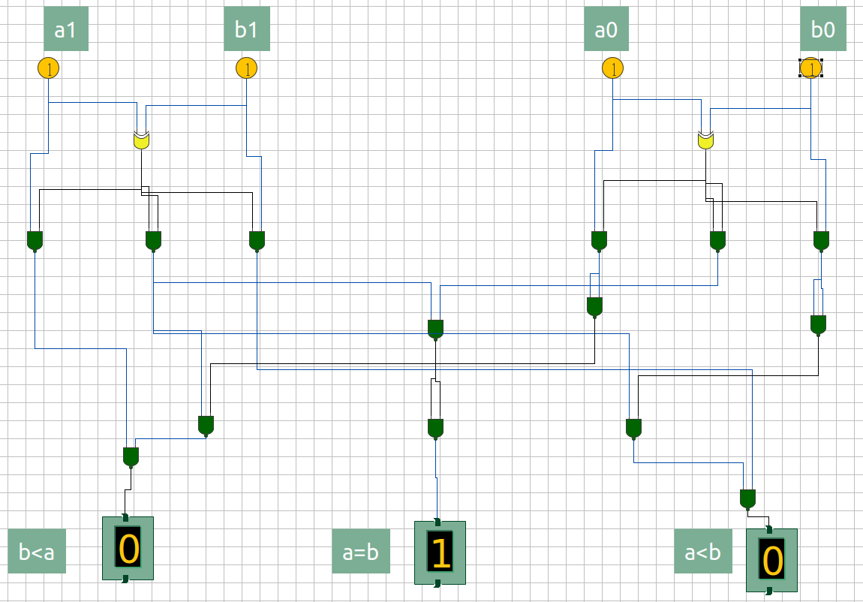

Figure 16: a1 = 1; a0 = 1; b1 = 1; b0 = 1

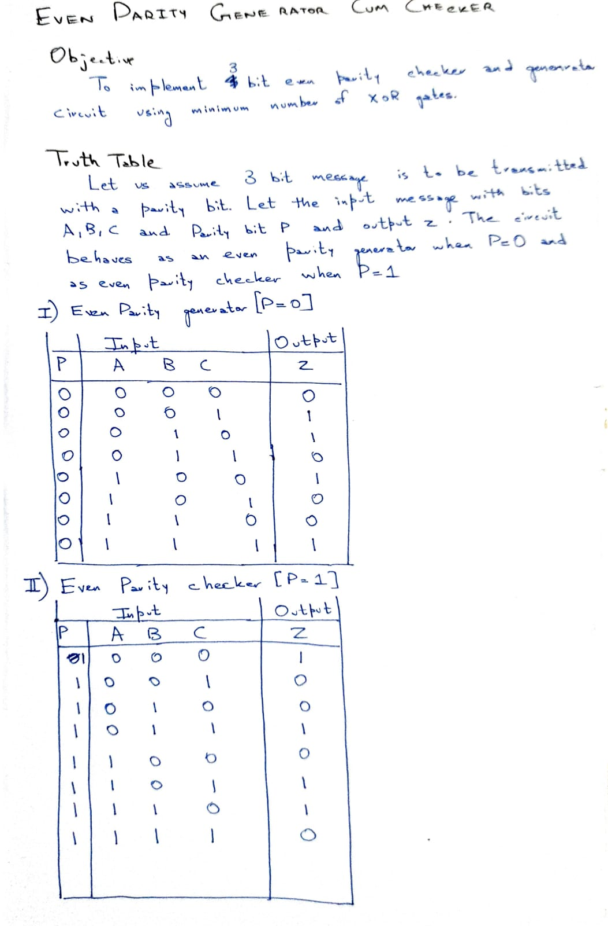

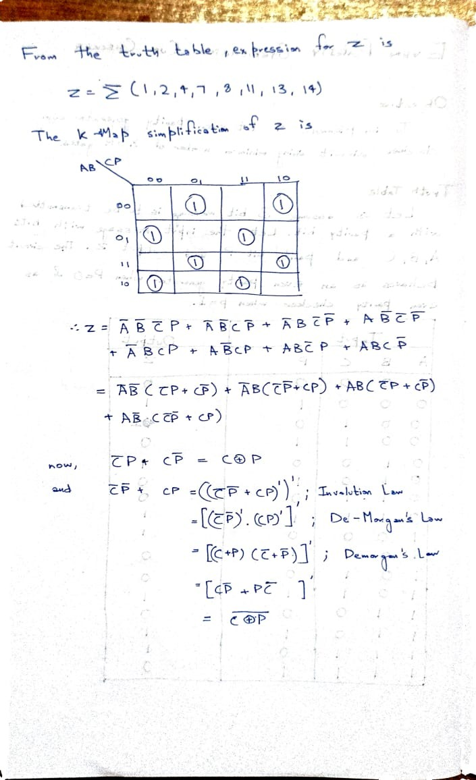

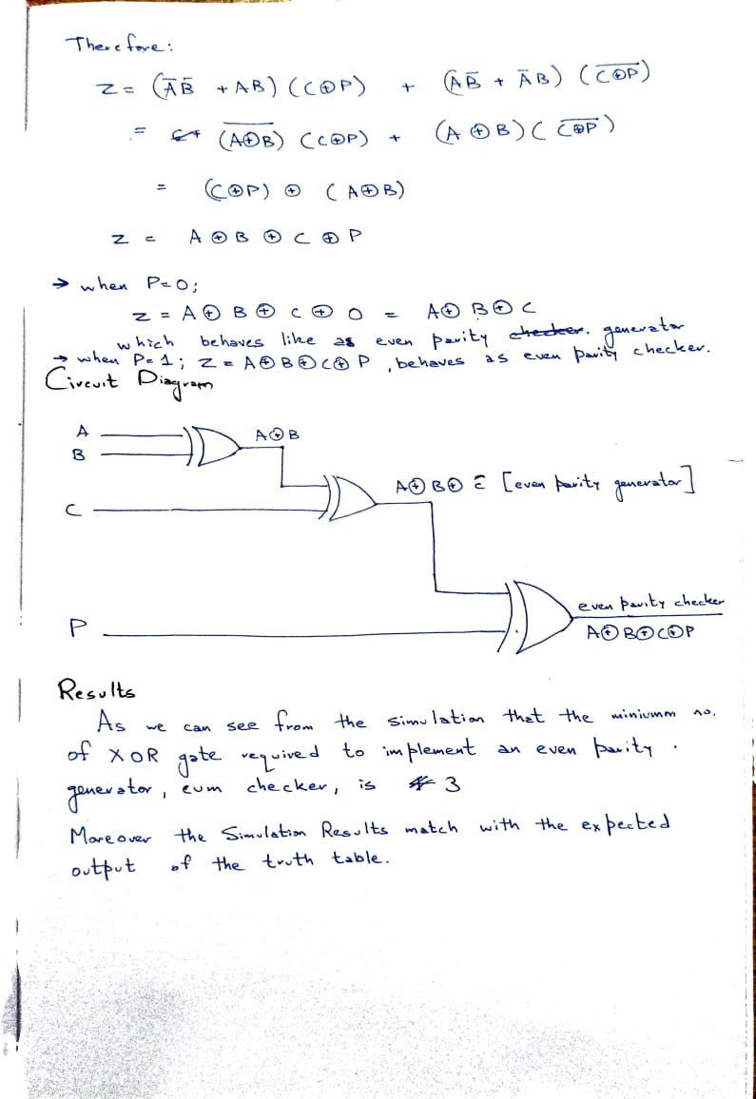

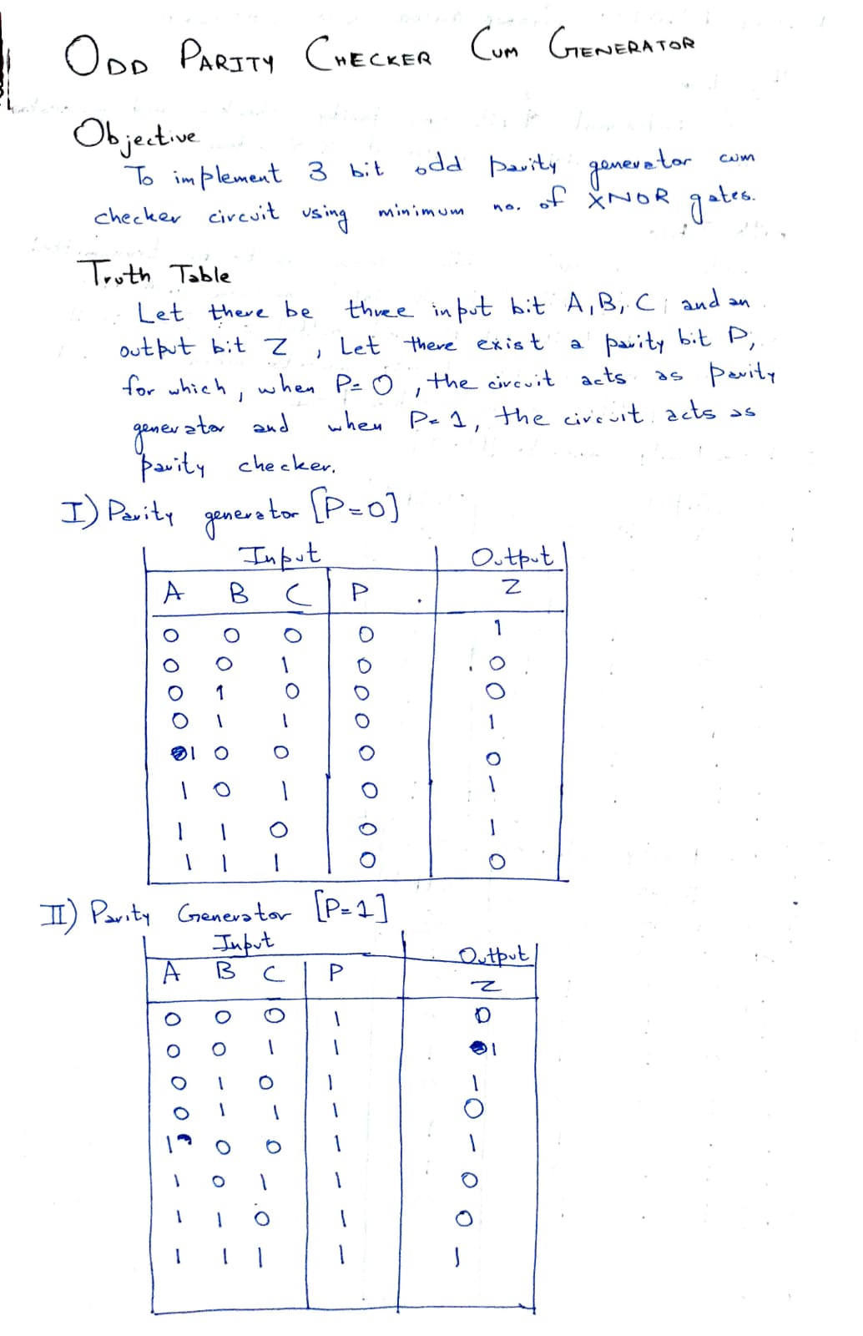

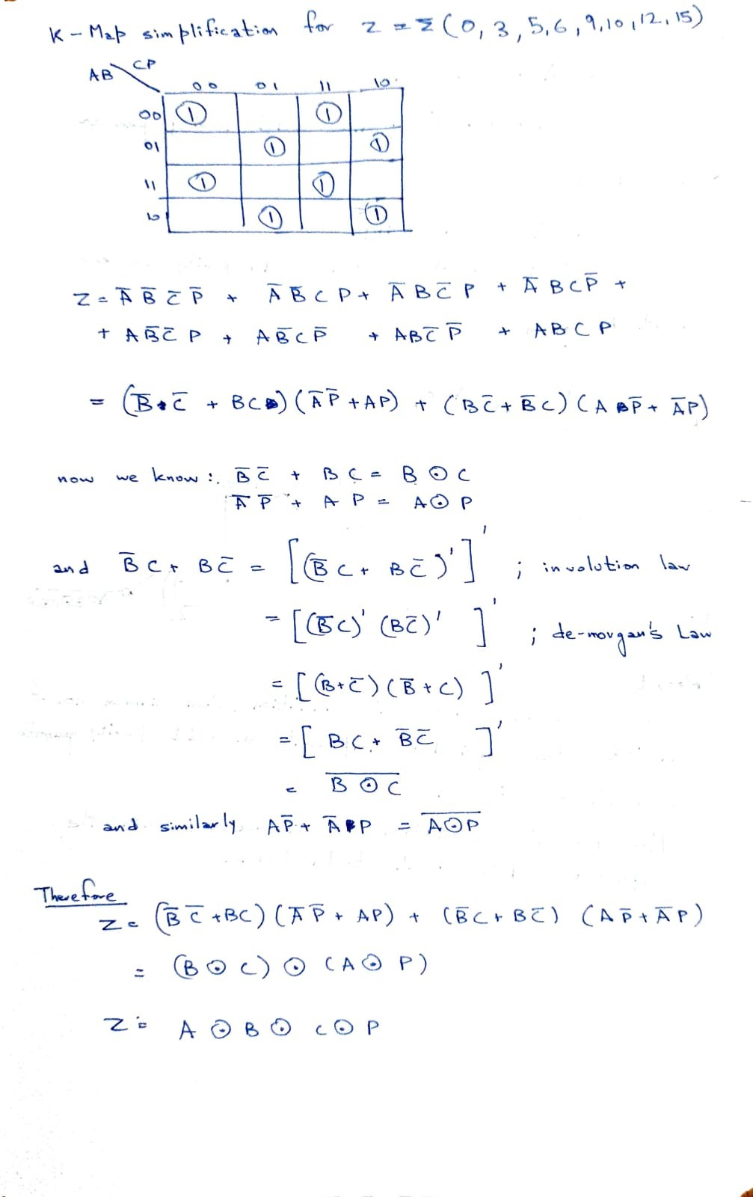

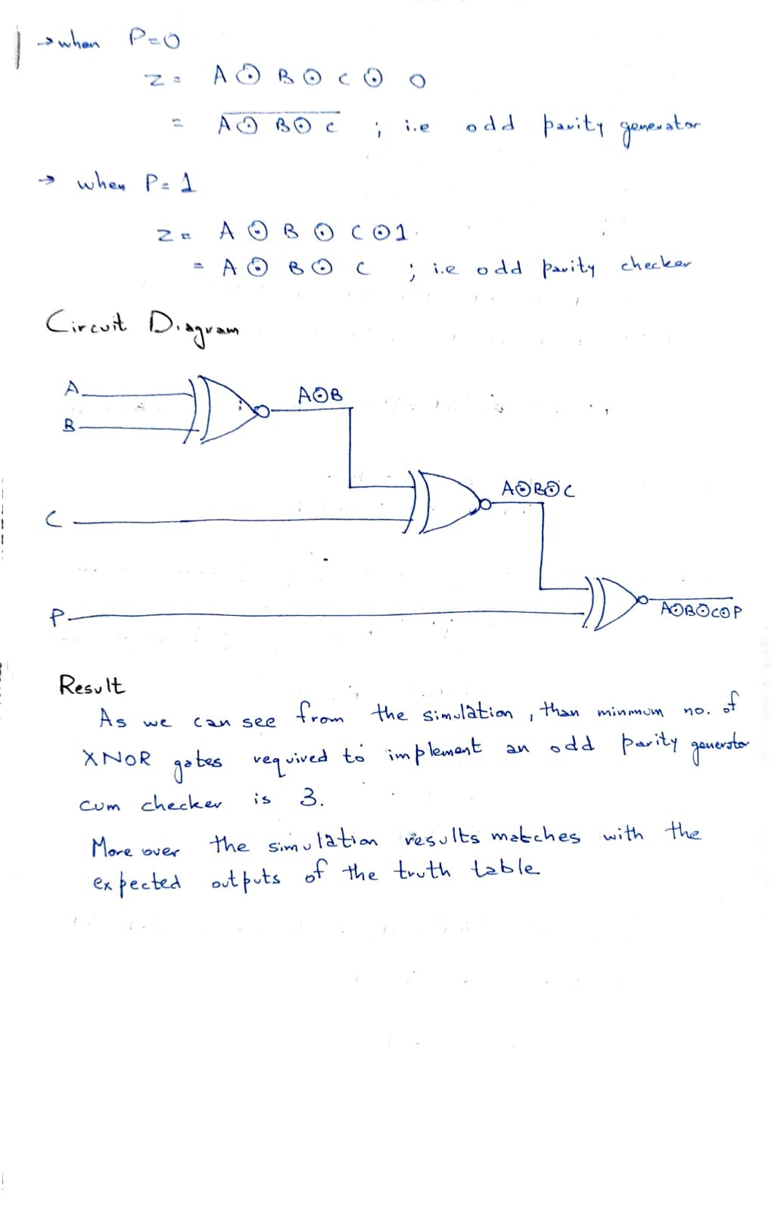

## Input / Output

Figure 2: P = 0; C = 0; B = 0; A = 1

Figure 1: P = 0; C = 0; B = 0; A = 0

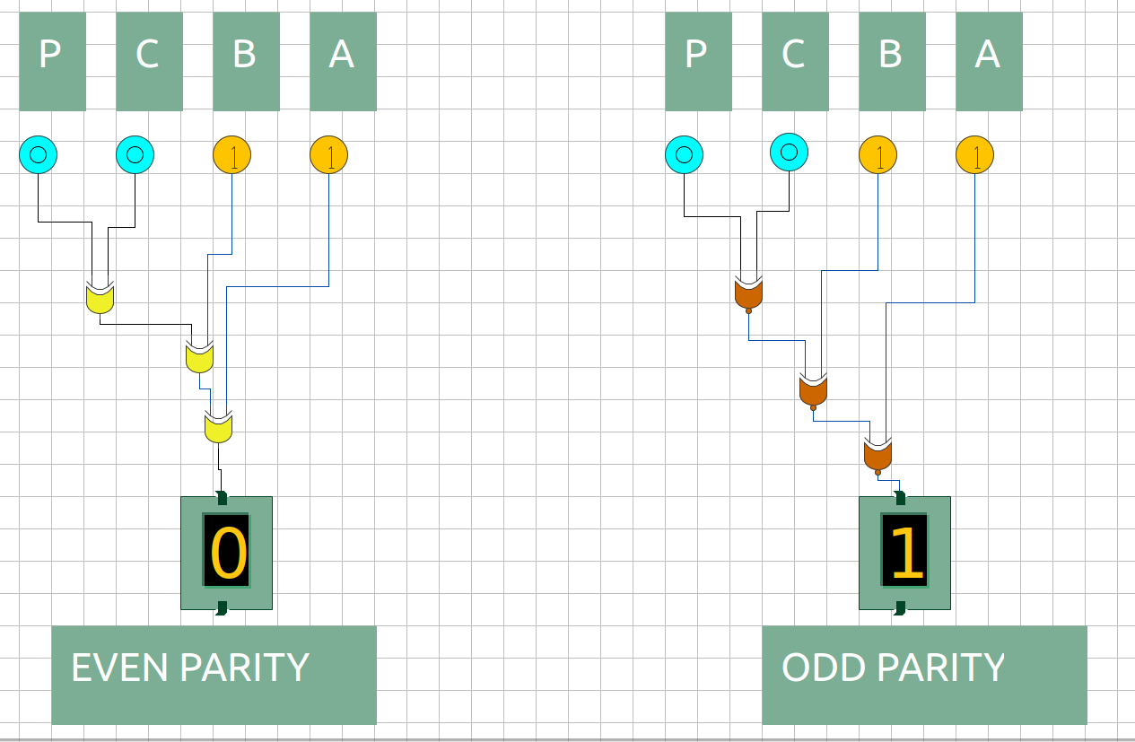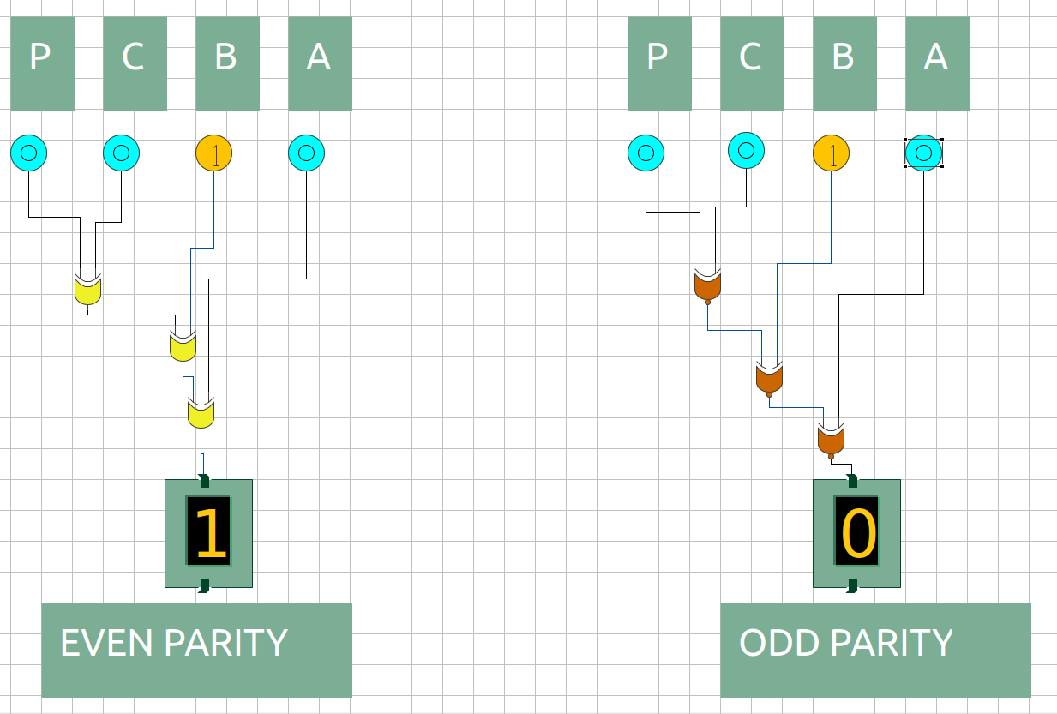

Figure 3: P = 0; C = 0; B = 1; A = 0

Figure 4: P = 0; C = 0; B = 1; A = 1

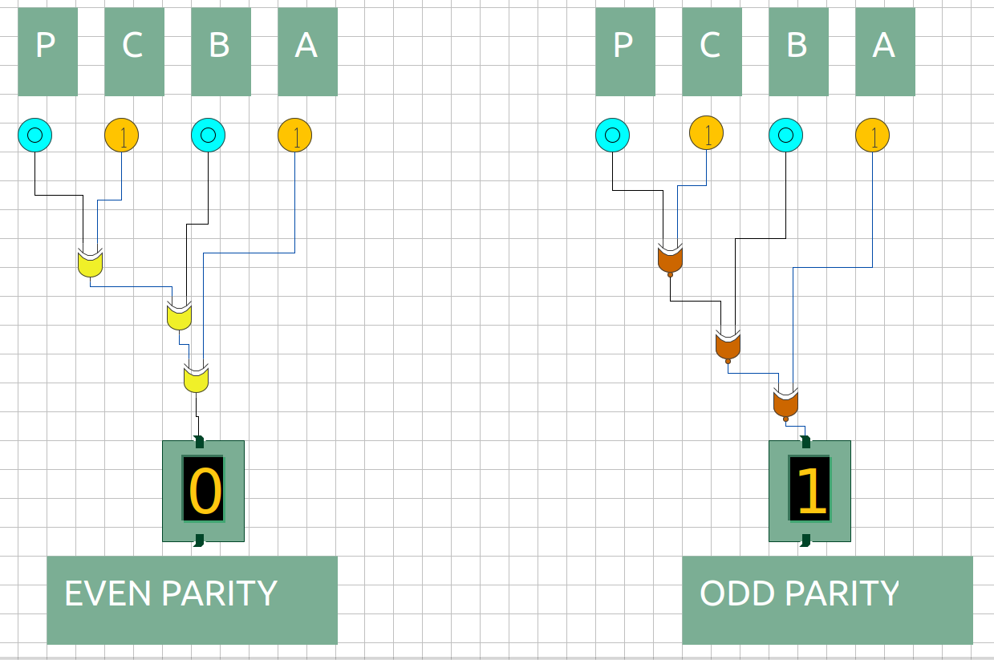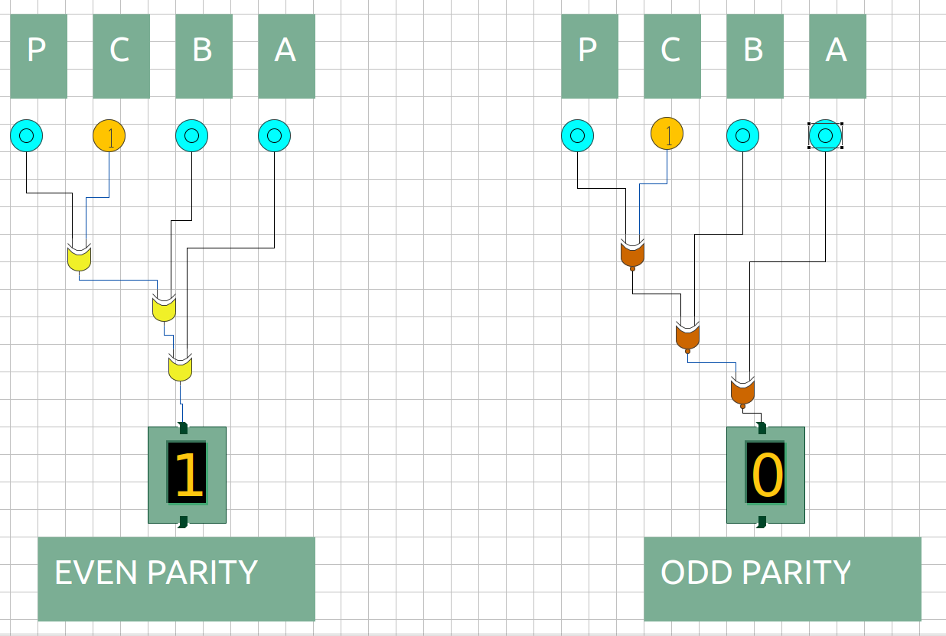

Figure 5: P = 0; C = 1; B = 0; A = 0

Figure 6: P = 0; C = 1; B = 0; A = 1

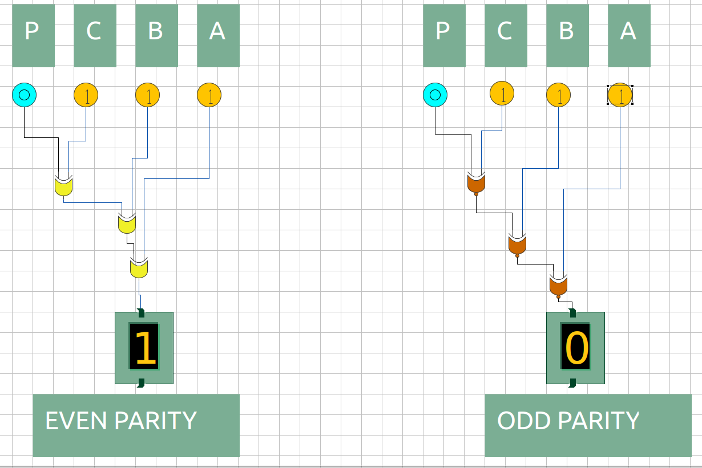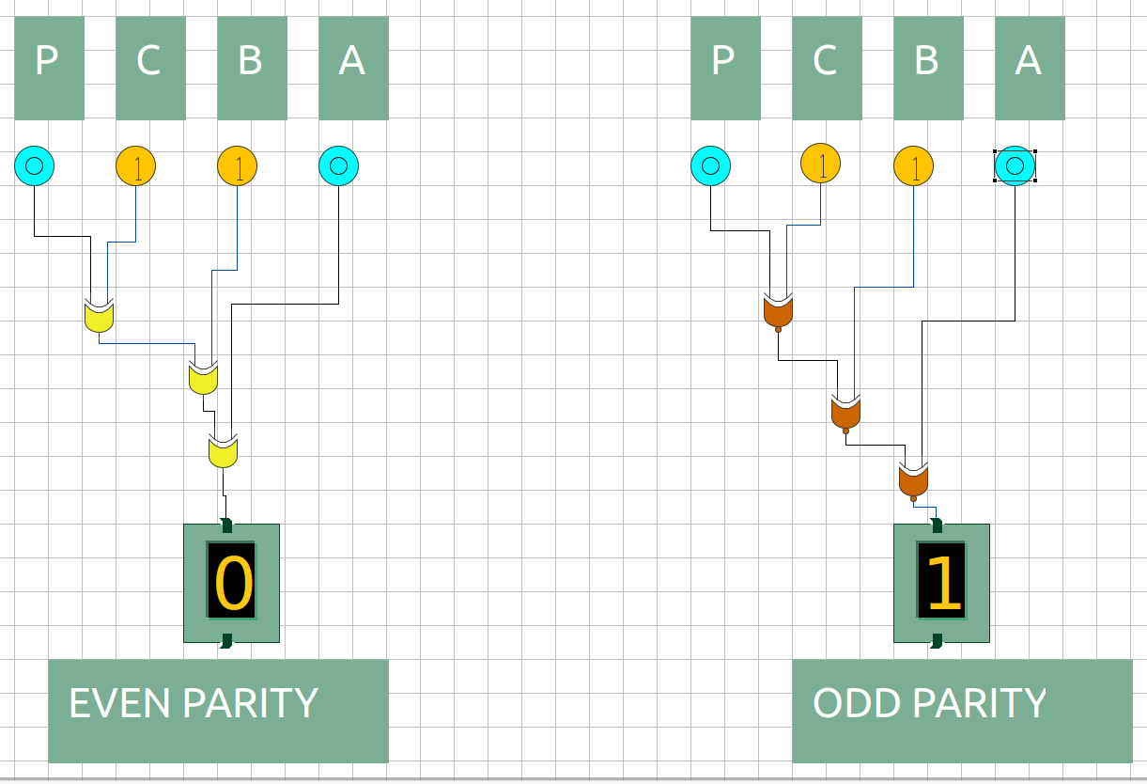

Figure 7: P = 0; C = 1; B = 1; A = 0

Figure 8: P = 0; C = 1; B = 1; A = 1

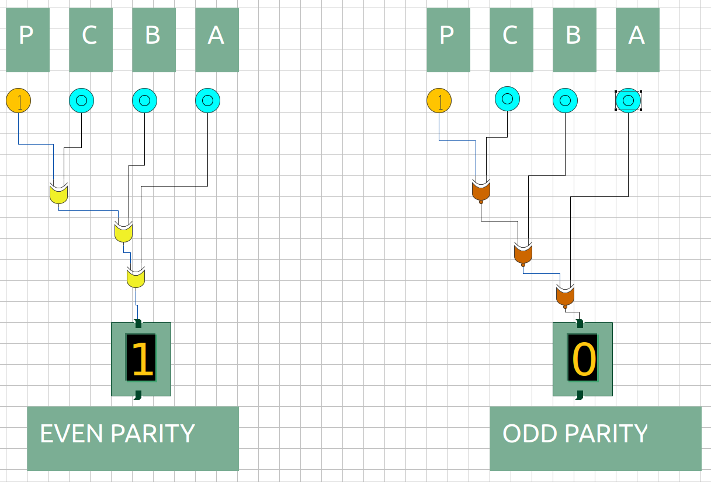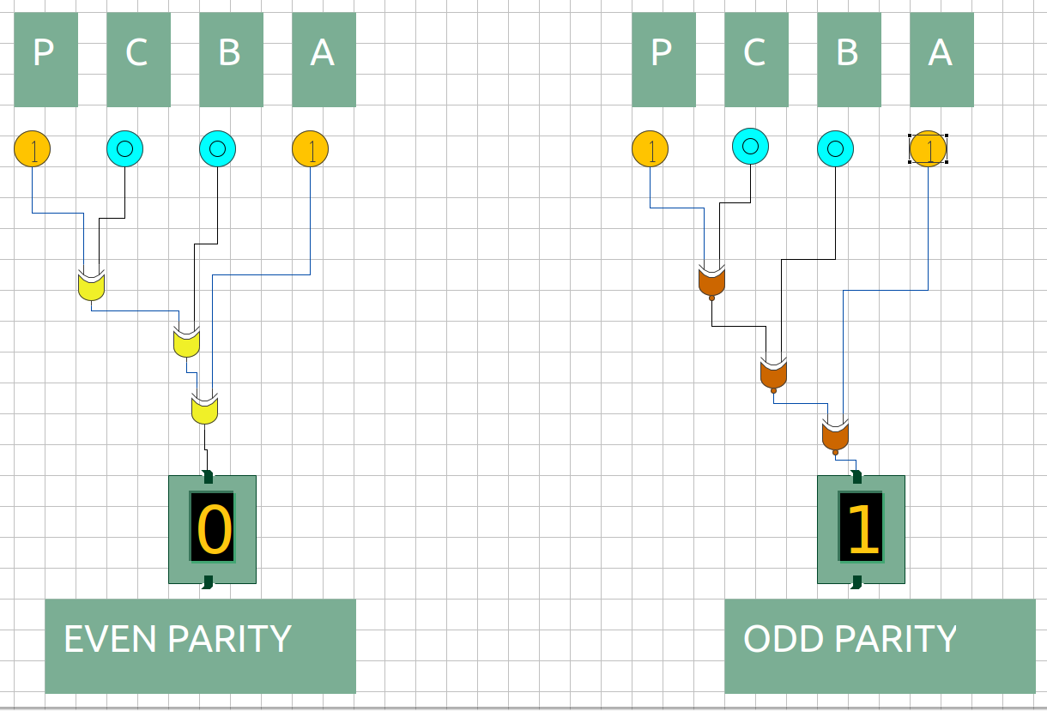

Figure 9: P = 1; C = 0; B = 0; A = 0

Figure 10: P = 1; C = 0; B = 0; A = 1

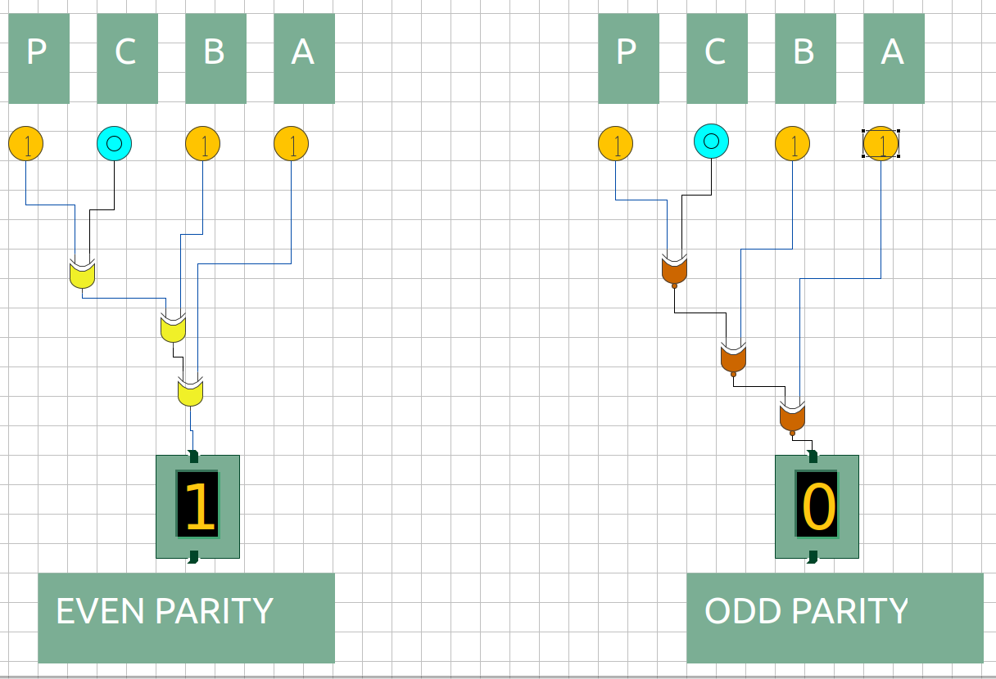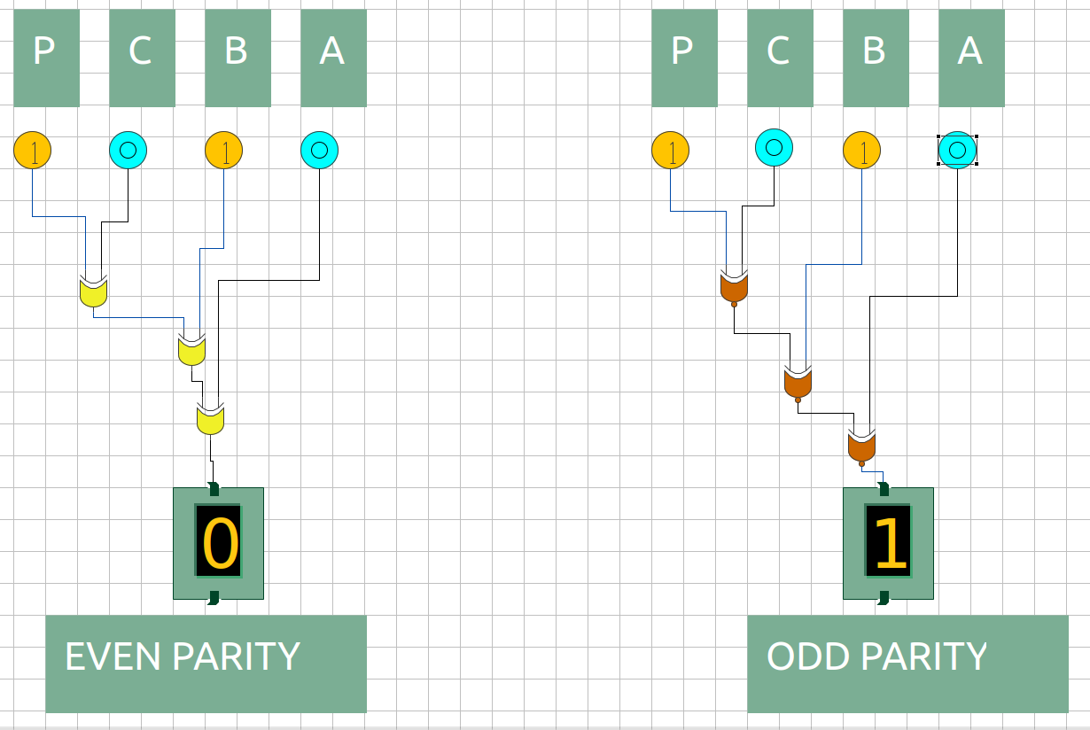

Figure 11: P = 1; C = 0; B = 1; A = 0

Figure 12: P = 1; C = 0; B = 1; A = 1

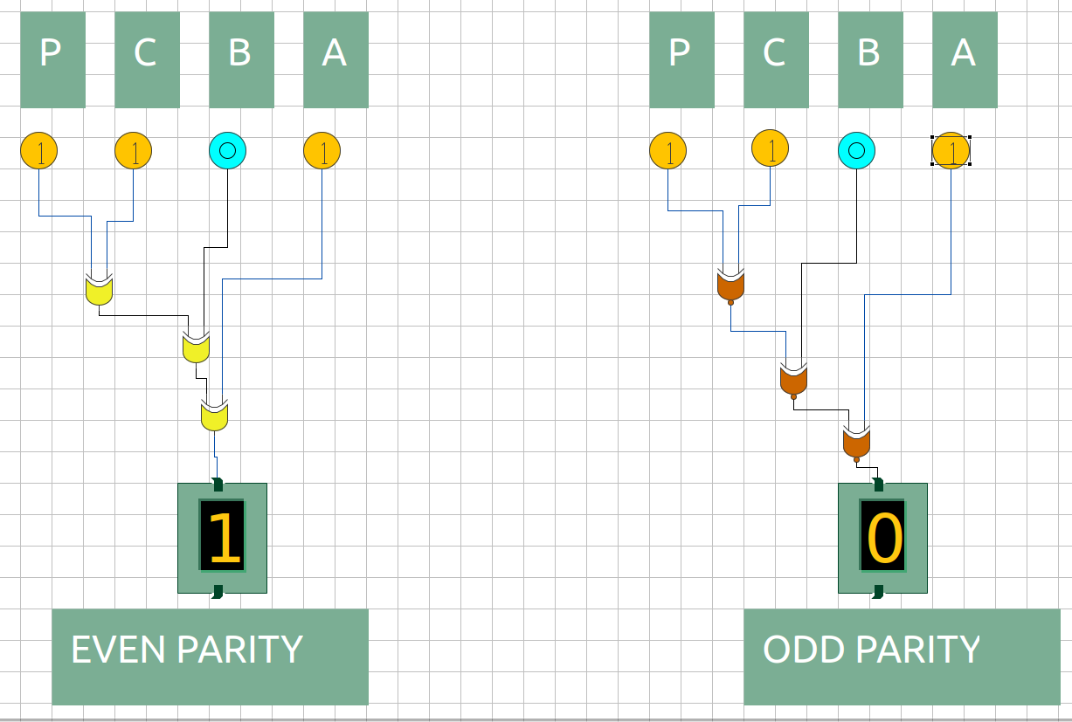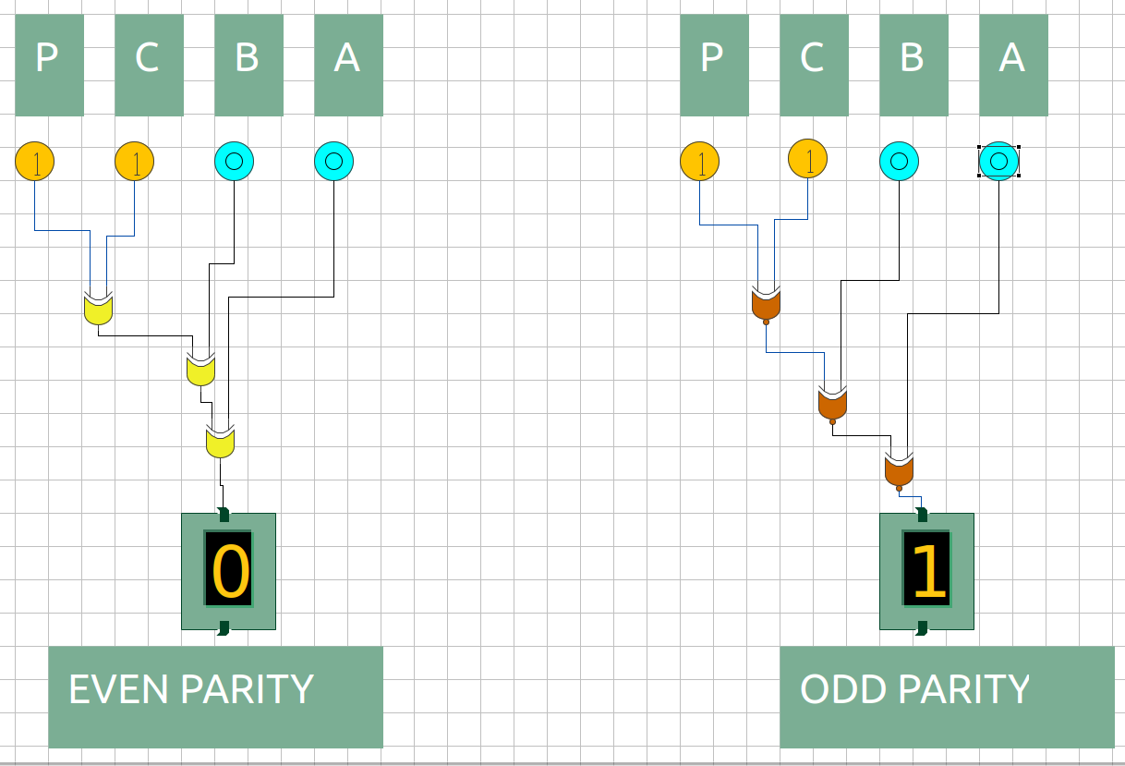

Figure 13: P = 1; C = 1; B = 0; A = 0

Figure 14: P = 1; C = 1; B = 0; A = 1

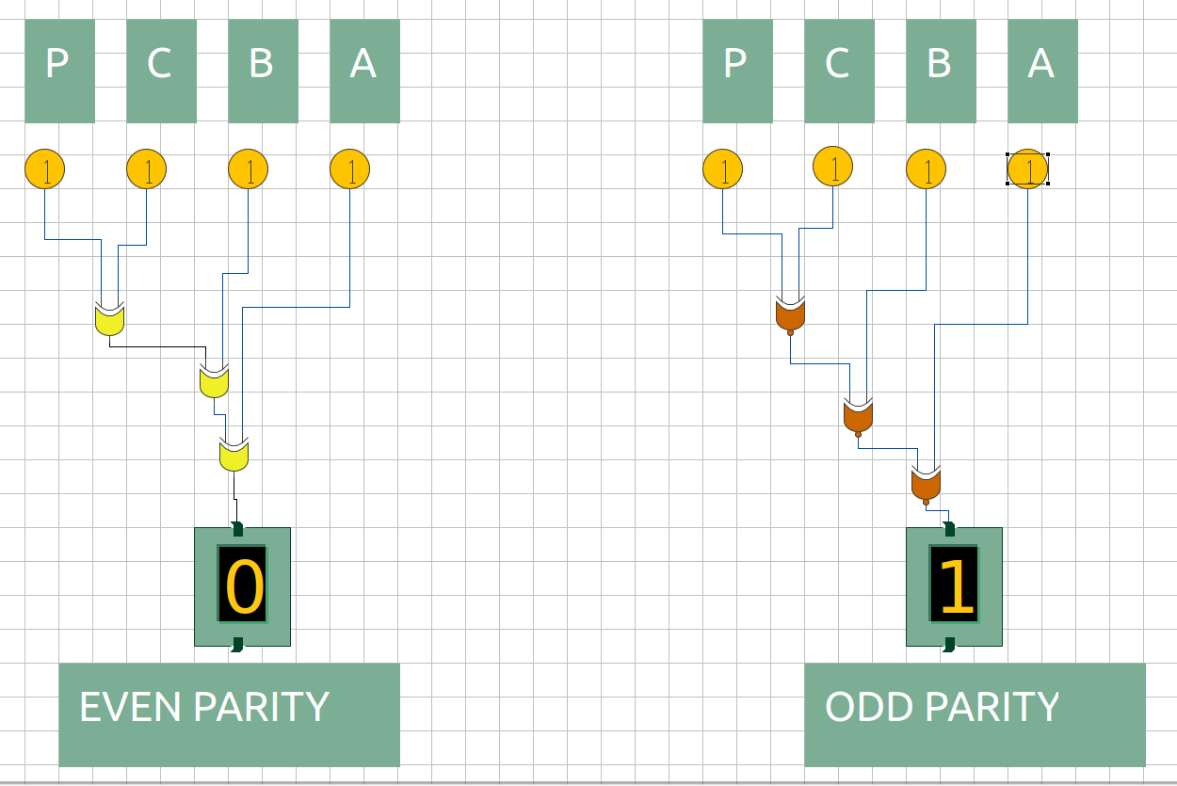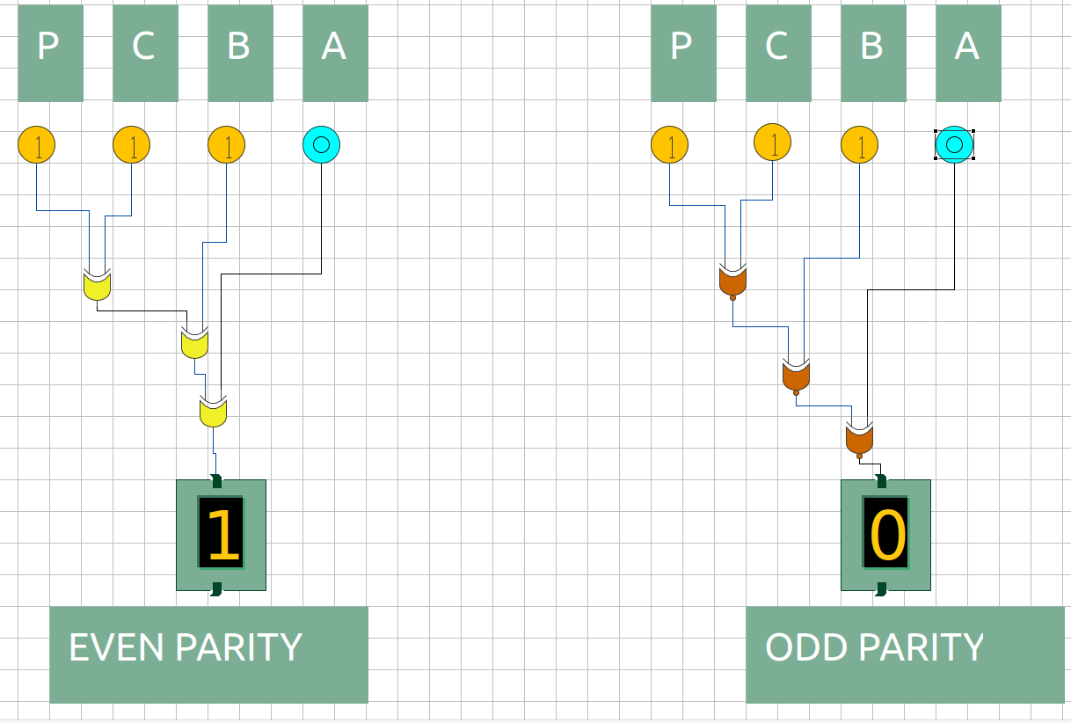

Figure 15: P = 1; C = 1; B = 1; A = 0

Figure 16: P = 1; C = 1; B = 1; A = 1